

**53rd DEUCE: June 2019**

**President’s Message:**

Welcome to the 53rd edition of the Deuce! Winter is here and the weather is perfect for a few more weeks on the grass courts before we move to the hard courts next month. Tony Kelly and his team at the Council have done a fantastic job looking after the courts this season, and will stop marking and mowing the grass courts on 21 June to let them rest and recover. This will be the last Deuce before the AGM on 27 July, and I would like to thank the dedicated committee members, volunteers and members who have worked so hard for the club. Particular thanks go to Sue Beresford who will be standing down after five years as Secretary, and Richard Beresford who has been Treasurer for the past six years. Both have worked tirelessly and made huge contributions to the club which are greatly appreciated by all. Mel Raich has been a great Social Captain for the past season and we look forward to her returning after a year away in Nepal (we hope there will be regular updates on her adventures). Also, thank you to Aidan Wilkinson for making up the sets, preparing tea and being a good warm-up partner!

**James Edwards, President**

********

Sue Richard Mel

**Notice of AGM and Nominations:**

Nominations are now open for election to the Committee. Nominations will close on 13 July 2019, 14 days before the Annual General Meeting on 27 July 2019. A member who wishes to be considered for election to the Committee at the AGM must nominate for election by advising the Secretary before the closing date. Committee positions are:

**2018/19 2019/20**

President James Edwards

Treasurer Richard Beresford

Secretary Susan Beresford

Captain Vlado Raich

Competitive Tennis Vice-Captain Ian Singleton

Social Tennis Vice-Captain Mel Raich

General Committee Member (Social) Mary Roche

General Committee Member (Membership) Olivia Richmond

General Committee Member (Sponsorship) Ian Hamer

General Committee Member (Refreshments) Rhett Hollick

While there is a lot of work done by the committee, we are also looking for non-committee volunteers for:

**2018/19 2019/20**

Hall Hire Bec Hall

Grounds and equipment

Communications (newsletter, website)

Social functions

**Membership Survey:**

Thank you to everyone for completing the recent membership survey. We had an excellent turnout with 83 responses, compared to 57 responses when we carried out the survey in 2014. The survey report will be distributed to members to read at your leisure. However, some key points worth noting are:

* Social opportunities and social play continue to be very highly rated.
* 79% of respondents rated their membership experience as excellent or very good, up from 71% in 2014.
* The top rated amenity was the Undercover Area.
* The lowest ranked amenity was the Change Rooms, no change from 2014.
* Dissatisfaction with fees was slightly lower at 9% compared to 11% in 2014.
* 81% of respondents felt the club is meeting its vision either extremely well or very well.
* A consistent theme related to access to courts and a desire for more evening and winter access.
* Grass was the preferred surface by a wide margin, however, only 10% of respondents said they would not or could not play on a hard court.
* Feedback on potential improvements backed up the committee’s shortlist with support for all the items. However, there was strongest support for adding lights to the central bay of grass courts. Converting Courts 2 and 3 to hard courts was ranked at 9 out of 10.

Based upon the survey results, the committee is preparing a Five Year Plan which will be considered at the AGM.

**Tennis West Volunteers Party**



David, Addy, Marie-Lise, Ruza, Simon and Vlado represented the club in style at the recent Volunteers Party! I think we know which ones are the real party animals don’t we!!

**The club celebrates Vlado’s 50 years at OPTC**

**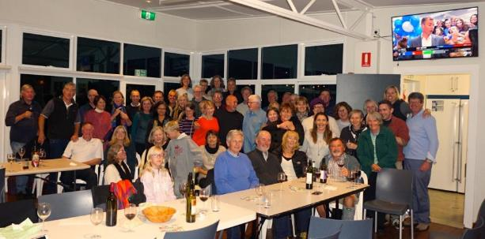**

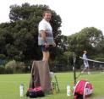****

**C:\Users\James\AppData\Local\Microsoft\Windows\INetCache\IE\B26RH822\psychedelic-1503541_640[1].png The Summer of Love came to OPTC in March**



































































LRG_DSC05776.jpg





























**Calendar**

Upcoming dates: keep an eye on updates to the OPTC Calendar - posted on our website

Saturday 22 June: Grass court maintenance ends

Saturday 29 June: Monthly BBQ

Saturday 13 July: Nominations for the committee close

Saturday 27 July: OPTC AGM

Saturday Mid-August: OPTC Wind-up Dinner

Notice that the Season Wind-Up Dinner will be in August (details to follow).

**Competition news from Ian Singleton**

**Adult Pennants:**

This summer we seeded 13 teams including two teams in the Saturday open divisions.  Of these 6 made the semi-finals with 4 going on to win the grand final.  The two losing semi-final teams were our ladies Saturday Division 3 team and Thursday night ladies Division 6.  Our young guns (Brendan, Ashley, Iain Stewart and Ian Hiew led us to victory on Saturdays with Jaimes Newman and I helping with a doubles rubber in our 2 game victory in the Division 7 grand final - Brendan’s win at number 1 leaving him undefeated for the season.  On Monday nights Jack, Shaun, Iain, Rhett and Drew along with Leoni, Debbie, Janine, Donna and Liv did a clean sweep bringing home both the men’s and ladies Division 1 flags.  On Sunday’s Ian, Brendan, Peter, Cliff (to name 4 of many) won the FAST4 Division 1 flag for the 3rd or 4th year in a row.

My thanks as ever to captains as without them the teams would not happen - Janine (Saturday and Monday), Liv, Tischa, Dean, Catherine, Gill, Betsy, Steph, Ian and Vlado.

Winter leagues are now in full flight with the ladies leading the way in numbers with 3 teams on Thursday nights and one on Tuesday mornings.  The men have two teams including a first (in my living memory) with a Saturday afternoon Division 1 team - so if you want to see some great tennis (how I wish I could have ever hit a ball that well) come down at 1:00pm on a Saturday - coming weeks are 8th, 15th and 29th June.

**Club Open Championships**

The club championships were run in the first two weekends of April with just the Men’s Singles running through to the 19th.  A year of huge change with new winners in all tournaments.  Iain Stewart who has been closing in on the Men’s title for a number of years defeated our Rhett our reigning champion and grass court maestro only to come up against the form player of the season in Brendan in the final.  Mark carried Brendan in the men’s doubles final (honest!) and partnered with Janine also won the mixed doubles although we never got to see one the anticipated final as Maddy dislocated her collar bone.

In the ladies, Charley Baxter won the family battle beating Janine in the semi-finals but could not get past Leoni who continued her form from the pennants season to win both the singles and doubles where she partnered with Janine to beat Charley and Maddy:

Men’s Singles:   Brendan Jones beat Iain Stewart

Men’s Doubles:   Brendan Jones and Mark Mccallum beat Ian Singleton and Jaimes Newman

Mixed Doubles: Mark Mccallum and Janine Carpenter beat Brendan Jones and Madeleine Shapshak (forfeit-injury)

Ladies Singles: Leoni Dwyer beat Charley Baxter

Ladies Doubles: Leoni Dwyer and Janine Carpenter beat Charley Baxter and Madeleine Shapshak

**Tournament Winners 2018/19 Season**

|  |  |  |
| --- | --- | --- |
| **Event** | **Winner/s** | **Runner/s Up** |
| **Handicaps** |  |  |
| 2019  Men’s Singles Handicap | James Edwards | Bob Stott |
| 2019  Ladies Singles Handicap | Soonyoung Kwon | Mary Roche |
| 2019  Men’s Doubles Handicap | Anthony Wild &  Alberto Pignatti | Mark Hanna &  Byron Hanson |
| 2019  Ladies Doubles Handicap | Ruža Ostrogonac &  Marina Berzins | Lesley Bell &  Sri Adiyanti |
| 2019  Mixed Doubles Handicap | Lesley Bell &  James Edwards | Carolyn Strahan &  David Arnold |
| 2019  Pidgeon Cup Doubles Handicap | Mary Roche &  Anthony Wild | Robyn Carroll &  Diane Watson |
| **Championships** |  |  |
| **Open** |  |  |
| 2019  Men’s Singles  Championship Open | Brendan Jones | Iain Stewart |
| 2019  Ladies Singles  Championship Open | Leoni Dwyer | Charley Baxter |
| 2019  Men’s Doubles  Championship Open | Brendan Jones &  Mark McCallum | Ian Singleton &  Jaimes Newman |
| 2019  Ladies Doubles  Championship Open | Leoni Dwyer &  Janine Carpenter | Charley Baxter &  Madeleine Shapshak |
| 2019  Mixed Doubles  Championship Open | Janine Carpenter &  Mark McCallum | Madeleine Shapshak &  Brendan Jones |
| **Social** |  |  |
| 2019  Men’s Singles  Championship Division 1 | Vlado Raich | Keith James |
| 2019  Ladies Singles  Championship Division 1 | Marina Berzins | Marie-Lise Schläppy |
| 2019  Men’s Doubles  Championship Division 1 | Peter McKay &  James Edwards | Graham Nicholson &  Vlado Raich |
| 2019  Ladies Doubles  Championship Division 1 | Gill Webb &  Janet Howieson | Gwen Stewart &  Paula Edwards |
| 2019  Mixed Doubles Championship Division 1 | Janet Howieson &  Graham Nicholson | Ruža Ostrogonac &  Vlado Raich |

**Juniors news from Matt Bull**

**OPTC Junior Club Championship results**

The junior club championships concluded at the end of March. We had some very entertaining matches and everyone who came down to watch thoroughly enjoyed the quality of tennis on display. We were very impressed with the sportsmanship and attitudes of all players.

We would like to say a very special thank you to Jacquie Chan, our sponsor from [Miss Chow's](http://click.icptrack.com/icp/relay.php?r=12518646&msgid=390948&act=P41N&c=829894&destination=http%3A%2F%2Fwww.misschows.com.au), for supporting the event and coming down on the finals day to help present the medals to our champions.

**Results (winners)**

* Mixed 10/U Singles - Julia Pedrini
* Mixed 10/U Doubles - Connor Icaza & Taj Dwyer
* Boys 11/U Singles - Daniel Winn
* Boys 11/U Doubles - Matthew & Daniel Winn
* Girls 11/U Singles - Naomi Vakadranu
* Boys 12/U Singles - Jake Eyers
* Girls 16/U Singles - Charley Baxter
* Boys 16/U Singles - Brendan Jones
* Boys 16/U Doubles - Brendan Jones & Michael Forman
* Parent & Child Doubles - Craig & Liam Dufty

***OPTC Adult Club Championships***

It is a proud moment when the junior players who have been training with Tennis Factory since we began at the club ten years ago start to make an impact in the adult club champs!

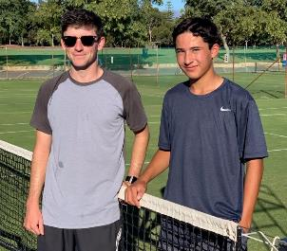Iain Stewart (now also a Junior Development Coach at the club) made the final again this year, on the way beating his nemesis Rhett Hollick for the first time.

Iain came up against an in-form Brendan Jones (also a trainee coach) with Brendan (16) taking out the final 6-4, 6-3.

Congratulations!

In the ladies event junior player Charley Baxter (15) made the final, losing to Leoni Dwyer.

It is incredibly rewarding watching our younger players transition to adulthood, not only playing some great tennis but watching them turn into mature young adults too.

We are so proud of you!

***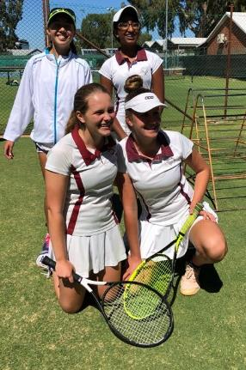Summer pennant round-up***

Of our 8 junior teams competing this summer, four made semi-finals. Even more impressively, three of those teams are competing in Division 1.

This season most of our teams were playing in higher divisions and older age groups which meant they were all challenged.

All players showed tremendous skills and great sportsmanship throughout the entire season.

Our girls 16/Under Div 2 team which consists of Charley B, Bella S, Isla M, Neemy L and Claudia W (currently injured) were the only victors in the grand final! Well done girls!

Girls Summer pennant winners  
Isla Macdonald, Neemyana Lathia, Isabella Setterfield and Charley Baxter (missing Claudia Wright).

***Winter pennants***

We have 6 junior teams competing in Tennis West league this winter in the following divisions –

* Orange Ball West Division
* Green Ball Division 1
* Green Ball Division 3
* Green Ball West Division
* Boys 14/U Division 2
* Girls 16/U Division 1

**Coaching news**

***Super 10 success***

We have a record 4 junior players (10 & under) from the club who have qualified for the winter season’s state Super 10’s season.

We have 2 boys (Daniel Winn and Lucas Icaza) and 2 girls (Naomi Vakadranu and Kendal Macdonald) who have made the final 16 players (boys and girls) to compete in a teams competition for the best players in the state which is held at the State Tennis Centre in Term 2.

*$50 private lesson offer for adults*

There is just 3 weeks remaining for our $50 private lesson special offer for adults with our senior staff. These lessons are conducted from 9-10am between Monday-Thursday. There are a couple of openings still available so get in quick before the offer ends (21st June). To book call *6365 2909* or email [*admin@tennisfactory.com.au*](mailto:admin@tennisfactory.com.au).

***July Tennis Camps***

We have Tennis Camps running both weeks of the holidays from Monday 8th – Friday 12th and Monday 15th – Friday 19th July. These camps are perfect for kids aged 4 – 14 years. For more info - [*https://tennisfactory.com.au/school-holiday-programs/*](https://tennisfactory.com.au/school-holiday-programs/)

***Community news***

For many years OPTC, Tennis Factory and Rosalie Primary School have had a fantastic partnership, with the school using the tennis courts during school time and Tennis Factory using the school’s playground during winter to conduct modified (Red ball) tennis lessons when the grass-courts are rested for renovations. The Head of Physical Education at the school, Jo Pierce and Matt recently worked together in applying for a Tennis Australia grant to mark red ball lines on the school’s back playground so now players can play using properly marked red ball courts. The grants don’t stop there with the potential for Tennis Australia to help the school to completely re-surface the back playground. Watch this space!

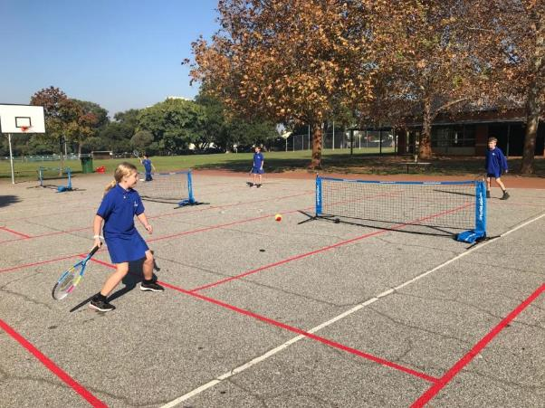

Kids enjoying the new red ball line markings for Rosalie Primary School using a Tennis Australia grant.

*NB: Please contact the editor at* [*info@onslowparktennisclub.com*](mailto:info@onslowparktennisclub.com) *with any newsworthy items, suggestions, points of interest that you would like to have circulated to other members throughout the season.*

**ACE DEALS - OPTC Sponsors:**

***Please support our sponsors who generously support the club***

**Centro Real Estate**



**MARINA BERZINS**

Sales Executive / Licensed Agent

0419 195 873

marina@centroestates.com.au.

**Miss Chow’s**

Miss Chow's Asian inspired eatery and dumpling house is located in Claremont and Whitfords.

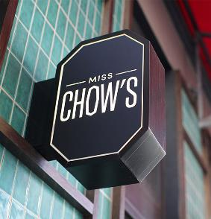

**Our local IGA**

****

**Tennis Only**

Don’t forget….. Onslow Park Tennis Club members get a 10% discount at Tennis Only. To get this discount online, members can use the code ONSLOW10 at check out, or to use it in store just mention the Club name!

******

**Magic Travel**



**Bank of Queensland, Subiaco**

****